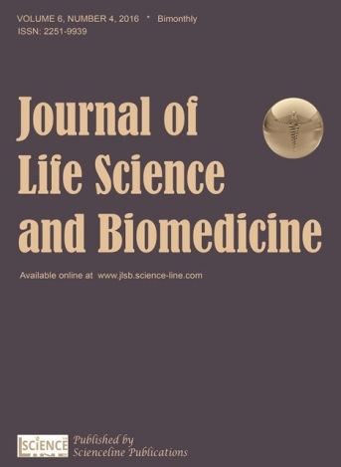

Scienceline Pub.
www.science-line.com

Journal of Life Science and Biomedicine
ISSN 2251-9939
www.jlsb.science-line.com

Signed copy must to be sent by mail to: editors@jlsb.science-line.com

DECLARATION OF THE AUTHORS

All authors of the manuscript titled:
……………………………………………………………………………………………………..
……………………

intended for publication in Journal of Life Science and Biomedicine (JLSB) declare that

- they agree to its publication after any amendments arising from the peer review
- they agree to the posting of the full text of this work on the web page of the journal and to the inclusions of references in databases available on the internet
- no results of other researchers were used in the submitted manuscript without their consent, proper citation or acknowledgement of their cooperation or material provided
- the results (or any part of them) used in the manuscript have not been sent for publication to any other journal nor have they already been published (or if so, that the relevant works are cited in this manuscript)
- submission of the manuscript for publication was completed in accordance with the publishing regulations pertaining to their workplace

AUTHORS OF THE MANUSCRIPT

E-mail name date signature

Updated in August, 2016
Available as PDF & WORD document at http://www.jlsb.science-line.com/index/

