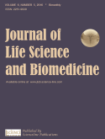
2018 SCIENCELINE
Journal of Life Science and Biomedicine
J Life Sci Biomed, X(X): XX-XX, 2018
License: CC BY 4.0 ISSN 2251-9939

Click

First 
^{1First}
^{2Second}
Corresponding author’s Email: author@institute.xxx

ABSTRACT  Delete  This template gives you guidelines and desired layout for final manuscript of Journal of Life Sciences and Biomedicine (JLSB). Abstract should not contain any equations, references, or footnotes. This article plays the role of a template as well as the guidelines for prospective authors who will have to prepare the final manuscript accepted for publication by JLSB. | Original Article  PII: S225199391800001-8
Rec. XX Nov. 2018
Acc. XX Jan. 2018
Pub. XX Jan. 2018
Keywords
3

INTRODUCTION

Main These instructions give you the guidelines to prepare papers for JLSB. Use this document as a template if you are using Microsoft Word 6.0 or later. Otherwise, use this document as an instruction set [1]. The electronic file of your paper will be formatted further at JLSB. Define all symbols and abbreviates used in the abstract. Do not delete the blank line immediately above and below the abstract; it sets the column format [2, 3].

MATERIAL AND METHODS

Submission to the Journal is on the understanding that:
1.The article has not been previously published in any other form and is not under consideration for publication elsewhere; 2.All authors have approved the submission and have obtained permission for publish work; 3.Researchers have proper regard for conservation and animal welfare considerations. Attention is drawn to the 'Guidelines for the Treatment of Animals in Research and Teaching'. Any possible adverse consequences of the work for populations or individual organisms must be weighed against the possible gains in knowledge and its practical applications. If the approval of an ethics committee is required, please provide the name of the committee and the approval number obtained.

Ethics Committee Approval
Experimental research involving human or animals should have been approved by author's institutional review board or ethics committee. This information can be mentioned in the manuscript including the name of the board/committee that gave the approval. Investigations involving humans will have been performed in accordance with the principles of Declaration of Helsinki. And the use of animals in experiments will have observed the Interdisciplinary Principles and Guidelines for the Use of Animals in Research, Testing, and Education by the New York Academy of Sciences, Ad Hoc Animal Research Committee. If the manuscript contains photos or parts of photos of patients, informed consent from each patient should be obtained. Patient's identities and privacy should be carefully protected in the manuscript.
Ethical approval (Example)
The review board and ethics committee of …………… approved the study protocol and informed consents were taken from all the participants.

MAIN FORMAT (RESULTS AND DISCUSSION)

Font type and size
The suggested length of a regular paper would be 4~10 pages, numbered and in this style. All content must be on one column. Zilla Slab, 14pt for the title (in capitalization for just first word of the title), 12, 10 and 9 pt(s) for other first page items as author's name, affiliations, and corresponding's email, respectively. 10pt for the main text and the section headings in the body of the text, double spaced, in A4 format with 2cm margins. All pages and lines of the main text should be numbered consecutively throughout the manuscript. The manuscript must be saved in both .doc/.docx formats. Abbreviations in the title are not allowed.
First page. Title (must be in brief and properly identified), Name of Author(s), Affiliation and Address, Running Title (7 words or less), and Corresponding Author (including institutional address and e-mail address) should be given.
Second page. Add Abstract (max 400 words) and Key words (max. 7 words) at the bottom of abstract in alphabetical order. The abstract should concisely state what was done, how it was done, principal results, and their significance in a comprehensive paragraph.

The following pages
The main text of manuscript should be written in the order of Introduction, Materials and Methods (should be complete enough to allow experiments to be reproduced), Results (should be presented with clarity and precision), Discussion (should interpret the findings in view of the results obtained in this and in past studies on this topic), Acknowledgment and References. Results and Discussion can be presented jointly if preferred. All pages containing the main text should be presented in single column.
Table. Table style and format should be per instructions for authors and recent issues. Each table should be on a separate page, numbered consecutively in Arabic numerals and supplied with a heading and a legend. Tables should be self-explanatory without reference to the text. The details of the methods used in the experiments should preferably be described in the legend instead of in the text. The same data should not be presented in both table and graph forms or repeated in the text. Abbreviations used in a table must be defined in that table. Tables are numbered with Roman numerals. Please do not include captions as part of the figures.
Figure and Graph. Figure legends should be typed in numerical order on a separate sheet. Graphics should be prepared using applications capable of generating high resolution GIF, TIFF, JPEG or PowerPoint before pasting in the Microsoft Word manuscript file. Use Arabic numerals to designate figures and upper case letters for their parts (Figure 1). Begin each legend with a title and include sufficient description so that the figure is understandable without reading the text of the manuscript. Information given in legends should not be repeated in the text. Figures to be printed in black and white should prepare in black and white. Abbreviations used in the figure must be defined in the caption of that figure.

Table 1. First
Items | 1st group | 2nd group
Item 1* | - | -
Item 2 | - | -
Item 3 | - | -
*P<0.05

Figure 1. first
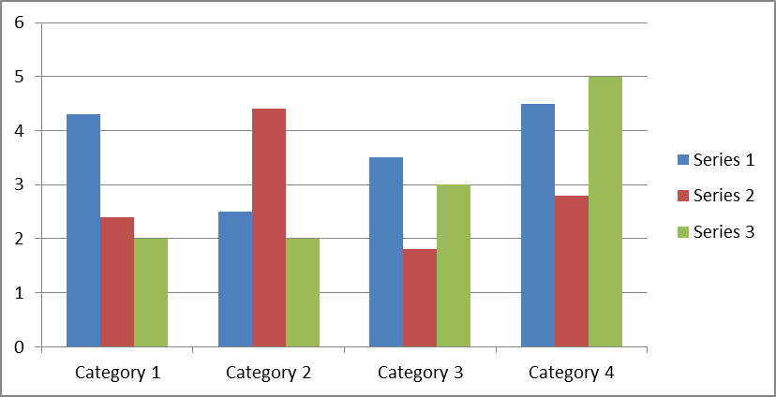

Graph 1. First.

CONCLUSION

Even though a conclusion may review the main results or contributions of the paper, do not duplicate the abstract or the introduction. For a conclusion, you might elaborate on the importance of the work or suggest the potential applications and extensions.

DECLARATIONS

Appendix
Appendixes, if needed, appear before the acknowledgment.

Authors’ Contributions
All authors contributed equally to this work.

Acknowledgements
This work was supported by …

Competing interests
Competing interests that might interfere with the objective presentation of the research findings contained in the manuscript should be declared in a paragraph heading "Competing interests" (after Acknowledgment section and before References). Examples of competing interests are ownership of stock in a company, commercial grants, board membership, etc. If there is no competing interest, please use the statement "The authors declare that they have no competing interests".

REFERENCES (Examples)

- Tanaka S, Yamamoto Т, Kubota D 2008. Predictive factors for surgical indication in adhesive small bowel obstruction. Am. J. Surg. 196(1): 23-27.
- Ermolov AS, Ilichev AS, Dzeytova RM, Bognitskaya TV. 2009. Prosthetic plasty in patients with strangulated umbilical hernia. The 3rd Congress of Moscow surgeons: Materials of Congress. [Article in Russian: Ермолов А.С., Протезирующая пластика у больных с ущемленной пупочной грыжей. Ермолов А.С., Ильичев В.А., Дзейтова P.M., Богницкая Т.В. III Конгресс Московских хирургов: Мат. съезда. Москва. 2009. С. 111.]

A reference style for EndNote may be found here. References should be numbered consecutively and cited in the text by number in square brackets [1, 2] (not by author and date). References should not be formatted as footnotes. Avoid putting personal communications and unpublished observations as references. All the cited papers in the text must be listed in References. All the papers in References must be cited in the text. Where available, URLs for the references should be provided.

Examples (at the text):
Smit [1] ...; Smit and Janak [2]…; Nurai et al. [3] reported that; ... [1], --- [2, 3], --- [3-7].
The references at the end of this document are in the preferred referencing style. Give all authors’ names; do not use “et al.” unless there are six authors or more. Use a space after authors’ initials. Papers that have not been published should be cited as “unpublished”. Papers that have been accepted for publication, but not yet specified for an issue should be cited as “to be published”. Papers that have been submitted for publication should be cited as “submitted for publication”. Capitalize only the first word in a paper title, except for proper nouns and element symbols. For papers published in translation journals, please give the English citation first, followed by the original foreign-language citation.

Examples (at References section):
For Journals:
1. Sukiman F, Imy SC and Hilman A. 2014. Short Communication: Growth of Seaweed Eucheuma cottonii in Multitrophic Sea Farming Systems at Gerupuk Bay, Central Lombok, Indonesia. Bioscience. 6(1): 82-85.
2. Hasan V, Sri Widodo M and Semedi B. 2015. Oocyte Diamater Distribution and Fecundity of Javaen Barb (Systomus Orphoides) at the Start of Rainy Season in Lenteng River, East Java, Indonesia insurance. J. Life Sci. Biomed. 5(2): 39-42.

For In press manuscripts (maximum 2):
Hasan V, Sri Widodo M and Semedi B. 2015. Oocyte Diamater Distribution and Fecundity of Javaen Barb (Systomus Orphoides) at the Start of Rainy Season in Lenteng River, East Java, Indonesia insurance. In press.

For symposia reports and abstracts:
Cruz EM, Almatar S, Aludul EK and Al-Yaqout A. 2000. Preliminary Studies on the Performance and Feeding Behaviour of Silver Pomfret (Pampus argentens euphrasen) Fingerlings fed with Commercial Feed and Reared in Fibreglass Tanks. Asian Fisheries Society Manila, Philippine 13: 191-199.

For Conference:
Skinner J, Fleener B and Rinchiuso M. 2003. Examining the Relationship between Supervisors and Subordinate Feeling of Empowerment with LMX as A Possible Moderator. 24th Annual Conference for Industrial Organizational Behavior.

For Book:
Russell, Findlay E, 1983. Snake Venom Poisoning, 163, Great Neck, NY: Scholium International. ISBN 0-87936-015-1.

For Web Site:
Bhatti SA and Firkins JT. 2008. http://www.ohioline.osu.edu/sc1156_27.hmtl.

